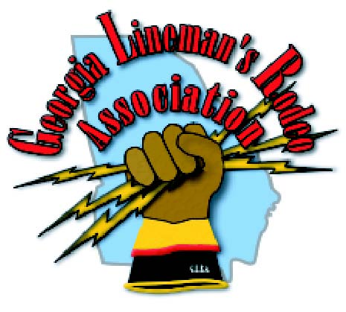
20thAnnual
Georgia Lineman’s Rodeo
May 2 – 3, 2014
CAMP JOHN HOPE, FFA CAMP
281 HOPE ENTRANCE ROAD
FORT VALLEY, GEORGIA 31030
Exhibitor Sponsorship Registration Form

Friday Luncheon Sponsor -$2000 One Sponsorship Available
Benefits Include: Recognition as the Official Rodeo Luncheon Sponsor; Signage at the sponsored luncheon; Recognition from the podium at awards banquet; Signage during the awards banquet; Exhibit space at rodeo field on Saturday; Exhibit space at the Friday luncheon; Printed recognition in banquet program and event brochure; Recognition on the Official Georgia Lineman’s Rodeo website as a Rodeo Luncheon Sponsor with your company logo and web link.

Awards Banquet Sponsor -$2000 One Sponsorship Available
Benefits Include: Recognition as the Official Rodeo Awards Banquet Sponsor; Recognition from the podium at awards banquet; Signage during the awards banquet; Exhibit space at rodeo field on Saturday; Exhibit space at the Friday luncheon; Printed recognition in banquet program and event brochure; Recognition on the Official Georgia Lineman’s Rodeo website as a Rodeo AwardsBanquet Sponsor with your company logo and web link.

Platinum Rodeo Event Sponsor -$1000 Seven Platinum Sponsorships Available
Junior Lineman’s Rodeo Sponsor - $1000 One Jr. Lineman Rodeo Sponsorship Available
Benefits Include: Sponsor’s name on event trophies and plaques; Recognition from the podium at awards banquet; Signage during the awards banquet; Premium exhibit space at rodeo field on Saturday; Sponsor’s name displayed on event tent during rodeo; Exhibit space at the Friday luncheon; Printed recognition in banquet program and event brochure; Recognition on the Official Georgia Lineman’s Rodeo website as a Platinum Level Sponsor with your company logo and web link.

Gold Rodeo Sponsor -$500
Benefits Include: Exhibit space at rodeo field on Saturday; Exhibit space at the Friday luncheon; Printed recognition in banquet program and event brochure; Recognition on the Official Georgia Lineman’s Rodeo website as a Gold Level Sponsor.

Silver Rodeo Sponsor -$250
Benefits Include: Printed recognition in banquet program and event brochure; Recognition on the Official Georgia Lineman’s Rodeo website as a Silver Level Sponsor.

Organizations are invited to support the 20th Annual Georgia Lineman’s Rodeo being held May 2–May 3, 2014 at Camp John Hope in Fort Valley, Georgia. The Georgia Lineman’s Rodeo promises to be a major event that will provide an exceptional venue for you to highlight your products and services essential to the electric power industry.
Don’t Miss Your Opportunity To Become An Official 2014Georgia Lineman’s Rodeo Sponsor!
General Inquiries and Exhibitor Registration should be directed to:
Georgia Lineman’s Rodeo Association | Karmen Scarbro  kscarbro@mariettaga.gov

Georgia Lineman’s Rodeo
May 3 - 4, 2014
Camp John Hope, FFA Camp
281 Hope Entrance Road
Fort Valley, GA 31030

Company

Contact Name

Address

City State Postal/Zip

Work Phone Cell Phone

Email

Sponsorship Level

$ 2000 Friday Vendor Show Sponsor
$ 2000 Awards Banquet Sponsor
$ 1000 Platinum Rodeo Event Sponsor
$ 500 Gold Rodeo Sponsor
$ 250 Silver Rodeo Sponsor

Will Exhibit On Friday Saturday Both Friday & Saturday

Registration Deadline is April 18, 2014

Payment Methods:
Credit Card Payments Accepted At: www.garodeo.com
Check Payable to Georgia Lineman’s Rodeo Association enclosed for $
Please Invoice Purchase Order Number
***PLEASE NOTE NEW ADDRESS & FAX ***

OR

Georgia Lineman’s
Rodeo Association

The Georgia Lineman’s Rodeo Association is a not-for-profit organization formed exclusively for charitable, scientific, and education purposes. The purpose of this organization is:

- To support and conduct an annual Georgia Lineman’s Rodeo
- To maintain a focus on safety and safe work practices
- To promote relationships among the electric utility companies in Georgia and the Southeast

Board of Directors

Chairperson
Electric Cities of Georgia
Bruce Whittington

Vice Chairperson
Secretary/Treasurer
Georgia Electric Membership Corporation
Tony Sinclair

Executive Committee

Chairperson
Jim Wright
Georgia Electric Membership Corporation

Vice Chairperson
Bill Bosch
Electric Cities of Georgia

Secretary/Treasurer
Brandon Wylie
Electric Cities of Georgia

Fax Registration Form To
Fax (706) 547-5051
Contact Karmen Scarbro
(770) 794-5222
Georgia Lineman’s Rodeo Association
Charles Mathis
6077 Middleground Rd.
Louisville, GA 30434
Please email questions to:
kscarbro@mariettaga.gov
www.garodeo.com

