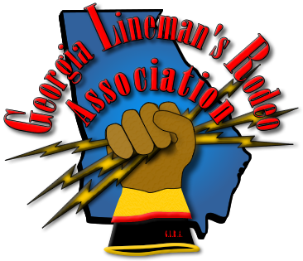
2015 Georgia Lineman’s Rodeo & Vendor Expo

Camp John Hope – FFA Camp
Friday May 1st - Saturday May 2nd

AGENDA

Friday, May 1, 2015

10-11am Chief Judges’ Meeting
10-2pm Vendor Show/Expo
Rodeo Registration – Release Forms Due @ This Time
Rodeo Sales - Apparel and Meal Ticket Sales

12:00 Noon - Lunch

1:00 pm - Judges’ Meeting - Judges receive their assignments & Official Shirts

Saturday, May 2, 2015

7:30 am - Apprentice Written Test
8:00 am - Opening Ceremony & Flag Raising
8:30 am - Rodeo Competition Begins
6:00 pm - Rodeo Awards Banquet

