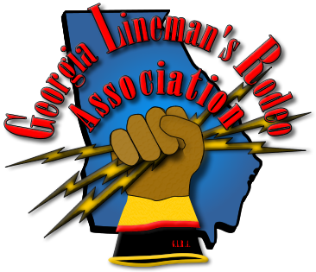
2014 Georgia Lineman’s Rodeo
&
Vendor Expo
Camp John Hope – FFA Camp
Friday May 2 - Saturday May 3
AGENDA
Friday, May 2, 2014

10-11am Chief Judges’ Meeting
10-2pm Vendor Show/Expo
Rodeo Registration – Release Forms Due @ This Time
Rodeo Sales - Apparel and Meal Ticket Sales

12:00 Noon - Lunch

1:00 pm - Judges’ Meeting - Judges receive their assignments & Official Shirts

Saturday, May 3, 2014

7:30 am - Apprentice Written Test
8:00 am - Opening Ceremony & Flag Raising
8:30 am - Rodeo Competition Begins
6:00 pm - Rodeo Awards Banquet

